**Progressive Education Society’s**

## **MODERN COLLEGE OF ENGINEERING**

Pune 411005.

­­



## A PROJECT REPORT ON

## **“Cricket Management System”**

### By

**Rutwik Karande- 37032**

**Amol More- 37043**

**Kirti Dalvi- 37008**

**Arpita Kanade- 37031**

Under the guidance of

**Mrs.Ketki M Gawali**

In partial fulfillment of T.E (Information Technology)

UNIVERSITY OF PUNE

PUNE 2017-18

## **Progressive Education Society's Modern College of Engineering, Pune-05. Department of Information Technology**

**2019-20**

**Certificate**



This is to certify that, project entitled “**Cricket Management System**”, Submitted by **Rutwik Karande, Amol More, Kirti Dalvi, Arpita Kanade** is record of bonafide work carried out by them, under the guidance of **Mrs.Ketki M Gawali**, in fulfillment of the requirement for the award of the T.E. of Bachelor of Engineering in **Information Technology,** University of Pune.

### Prof. Ketki M. Gawali Prof. Mrs. S. D. Deshpande

### GUIDE H.O.D (IT)

Date: Place: Pune

# **ACKNOWLEDGEMENT**

I take this opportunity to express my profound gratitude and deep regards to my guide Ms. Ketki M. Gawali for her exemplary guidance, monitoring and constant encouragement. The blessing help and guidance given by her time to time shall carry me a long way in journey which I am about to embark.

I am obliged to all the teachers of Information Technology department for the valuable information provided by them. I am grateful for their cooperation.

### ABSTRACT

Nowadays, most of the sport management system is having problems like offline registration, manage single tournament, manage statistics, etc. To overcome all those problems, we are proposing the Cricket Management System with utilities like different tournament registration, automatic or manually match schedules, statistics for the tournament, maintaining a log. In our proposed system tournament owner will register in the system and create a new tournament. Players can also register team members and player profiles. Then the system will schedule the matches of the tournament. The system will provide a registration system for players to input their data.

**CRICKET MANAGEMENT SYSTEM**

### INDEX

|  |  |  |
| --- | --- | --- |
| Sr. No. | TOPIC | PG. NO. |
| 1 | Introduction   * 1. Overview   2. Literature Reviews   3. Proposed System | 5  5  6 |
| 2 | Problem Definition and Scope  2.1 Problem Statement  2.2 Description of Problem  2.3 Scope | 7  7  7 |
| 3 | System Requirement Specification | 8 |
| 4 | Module Description | 9 |
| 5 | Feasibility Study | 11 |
| 6 | Functional Model and Description  6.1 Design (ER Diagram)  6.2 DFD Diagram  6.3 Sequence Diagram  6.4 Schema Diagram  6.5 Use Case Diagram | 12  13  14  15  16 |
| 7 | Graphical User Interface / Screen Shots | 22 |
| 8 | Future Scope | 29 |
| 9 | Conclusion | 30 |
| 10 | References | 31 |

1. **INTRODUCTION**
   1. **Overview**

Most of the sports management systems are paper-based. This increases manual work of registering players, managing single tournaments, managing statistics and logs of players, teams, and tournaments. While handling all these data manually there is a concern of human error. The sports culture is always a cut-throat occupation. There cannot be a chance for an error. Lots of people occupation depends on sports. Our team thoroughly brainstormed over this issue. We aim to provide a utilitarian solution to tackle this problem.

* 1. **Literature Reviews**

**Literature Review**

For literature survey, we have visited websites related to our system. We have also reviewed some patent as a part of project activity for literature survey. We have visited website [www.cricket.com](http://www.cricket.com/) and [www.victroclub.com](http://www.victroclub.com/) for literature survey

**System Analysis**

In system analysis part, we have studied about requirement specification of our project. There is included functional and non-functional requirement of our project. We have also designed software requirement specification called SRS for our system.

**Basic Implementation**

In this part, we have made GUI of our project

* 1. **Proposed System**

The proposed Cricket Club Management System is completely automated. The proposed system will ensure correct data entry for every player registration. An admin panel will be able to update, delete the entry if some changes are to be made. This Web Application is completely user friendly. The match scheduling and displaying the schedule is done via admin panel. This will come in handy to

1. **PROBLEM DEFINATION AND SCOPE**

**2.1 Problem Statement**

To create a website that provides online interface for registration of various cricketing events

**2.2 Description of Problem**

Now a days, most of the sport management system is having problems like offline registration, manage single tournament, manage statistics and maintaining log of players, team and tournaments. It is also difficult to manage multiple tournaments and to remind player before the match incase player forget the match day. So, our proposed system will allow different tournament registration, automatic or manual match scheduling and provide notifications to player via android applications.

**2.3 Scope**

The System would store all the games data of matches played between different teams. A

cricket fan would be much delighted to look up for scores and key moments from matches

through this system. It will be easier for team scouts to look up for new talent for their teams.

Hence, the deserving player will get a great opportunity that he or she wants to showcase their talent.

1. **SYSTEM REQUIREMENT SPECIFICATION**

**3.1** **Software Requirements**

3.1.1 Operating system: Windows, Linux.

3.1.2 Web Server: Apache 2.2.4

3.1.3 Database: MySQL 8.0

3.1.4 Scripting Language: PHP: Hypertext Preprocessor and

3.1.5 Browser: Google Chrome

**3.2 Hardware Requirements**

3.2.1 PC with 250 GB or more Hard disk

3.2.2 PC with more than 2GB RAM

3.2.3 The program will communicate with hard drive (the filesystem and database) via the appropriate PHP code

3.2.4 The user can communicate through browser using keyboard and a display through graphical interface displayed on user’s screen.

1. **Modules**

● Admin

➢ Admin can upload news.

➢ Admin can approve players and tournaments.

➢ Admin manage all data

● Player

➢ Players can register in the tournament.

➢ Players can view their profile.

➢ Players get notification via android application.

➢ Players can view details of different matches and different tournaments.

➢ Players can search tournaments after registration in the system.

➢ Players can view different match schedules.

● Team

➢ Team owner would be able to select 11 players from team using simple dropdown menu option.

➢ Selected Player will be simply get notified abput position in team.

● Match Scheduling

➢ Admin will be able to fix matches in between teams, date and timing of matches.

➢ The matches arranges can be simply viewed using display option in homepage.

● Contact us

➢ A simple contact us page for user to give feedback oabout website.

● About us

➢A simple about us page telling the vision and objective of website.

1. **FEASIBILITY STUDY**

Many feasibility studies are disillusioning for both users and analysts. First, the study often presupposes that when the feasibility document is being prepared, the analyst is in a position to evaluate solutions. Second, most studies tend to overlook the confusion inherent in system development- the constraints and the assumed attitudes.

1. **Economic Feasibility**

Economic analysis is the most frequently used technique for evaluating the effectiveness of a project. More commonly known as cost benefit analysis. In this procedure we determine the benefits that are expected from a player a proposed system and compare them with costs. We found the benefits outweigh the costs; we have taken this decision to design and implement this project in a very cost efficient way.

1. **Technical Feasibility**

This is concerned with specifying equipment and software that will successfully satisfy the user requirement. The technical needs of the system may vary considerably, but might include the facility to produce live changes is the score card of the matches which have taken place and its response time under certain conditions. Also, the ability to process the enrollment of players is made easy in this database. Facility to communicate data to distant location is made easy.

After examining technical feasibility, we give more importance to the configuration of the system than the actual make of hardware. The configuration gives the complete picture about the system's requirements.

1. **Functional Model and Description**
   1. **ER DIAGRAM**

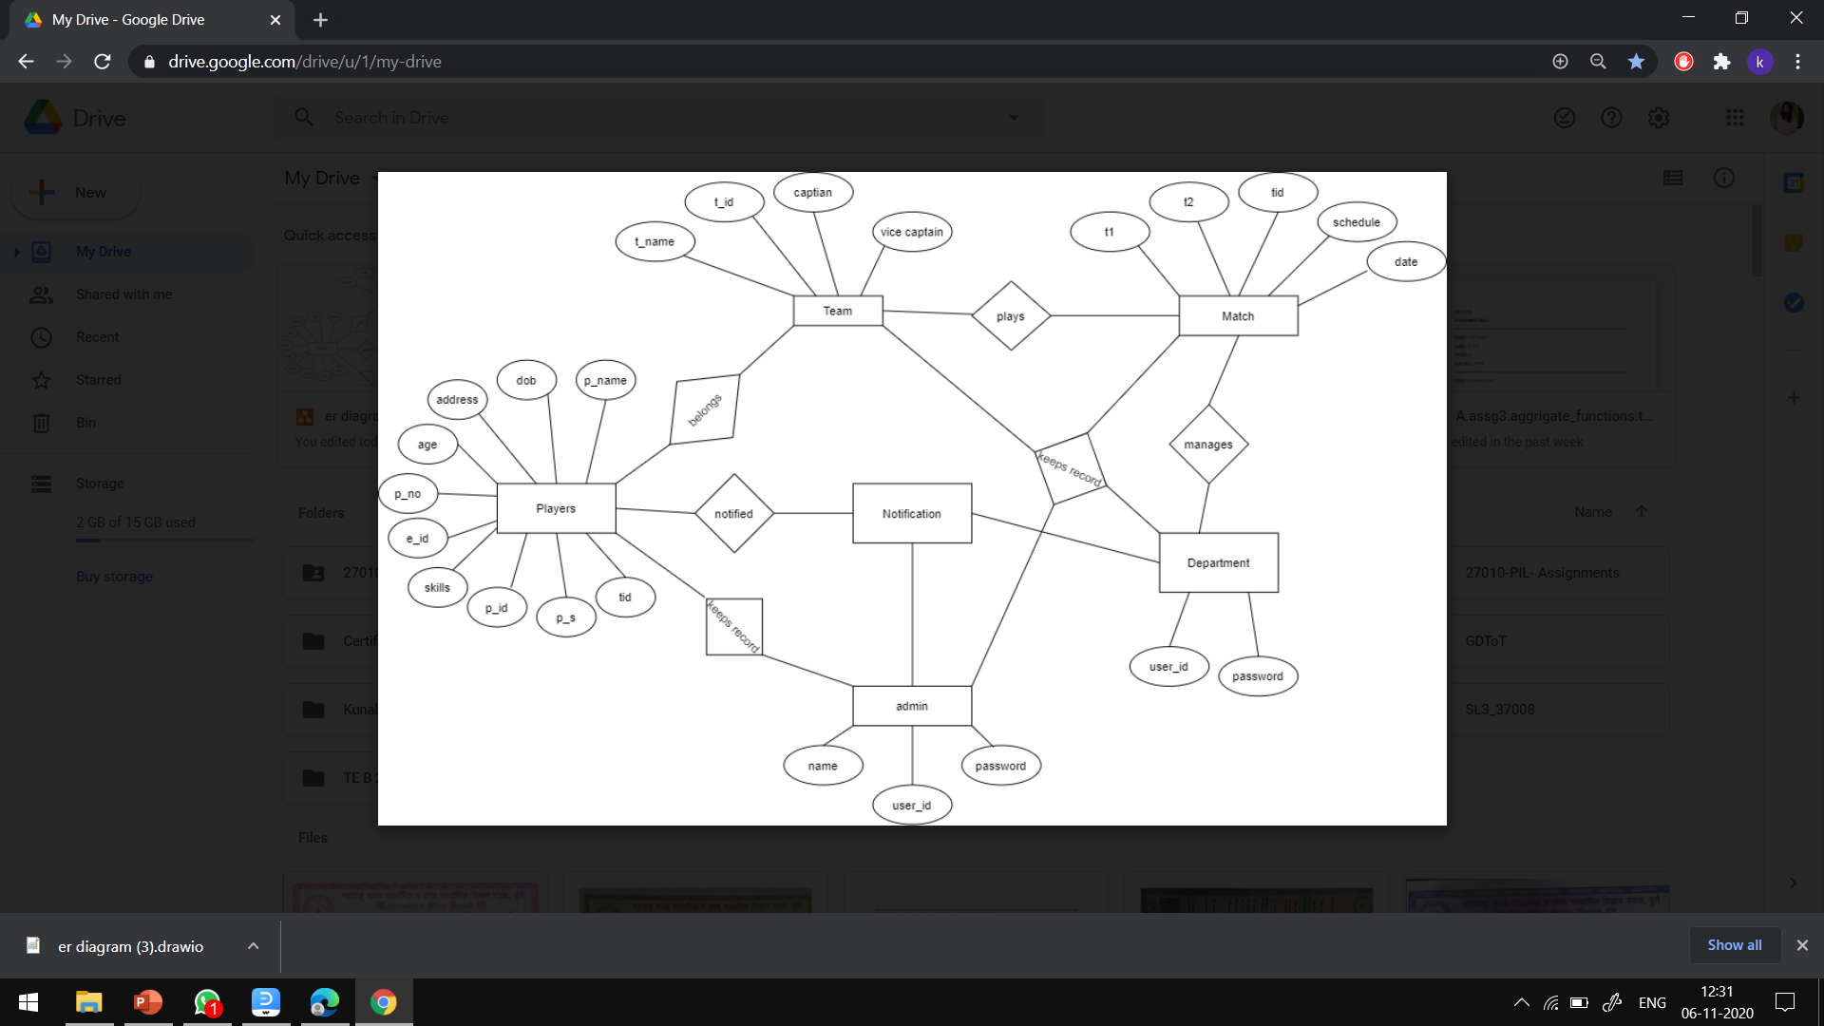

**6.2 Data Flow Diagram**

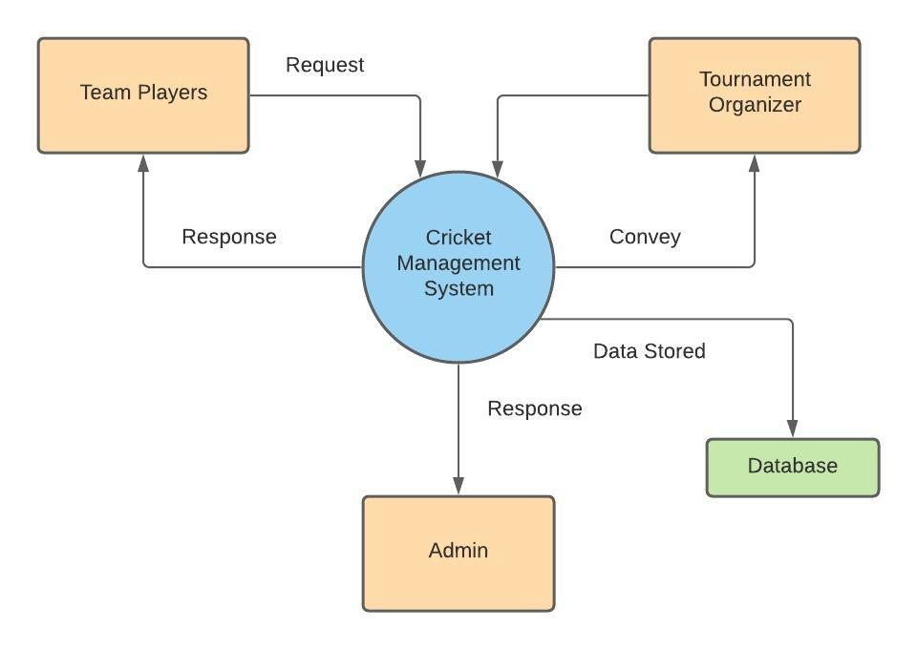

**6.3 Sequence Diagram**

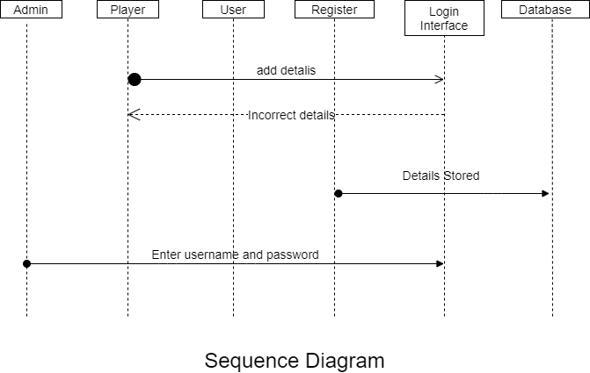

**6.4 SCHEMA DIAGRAM**

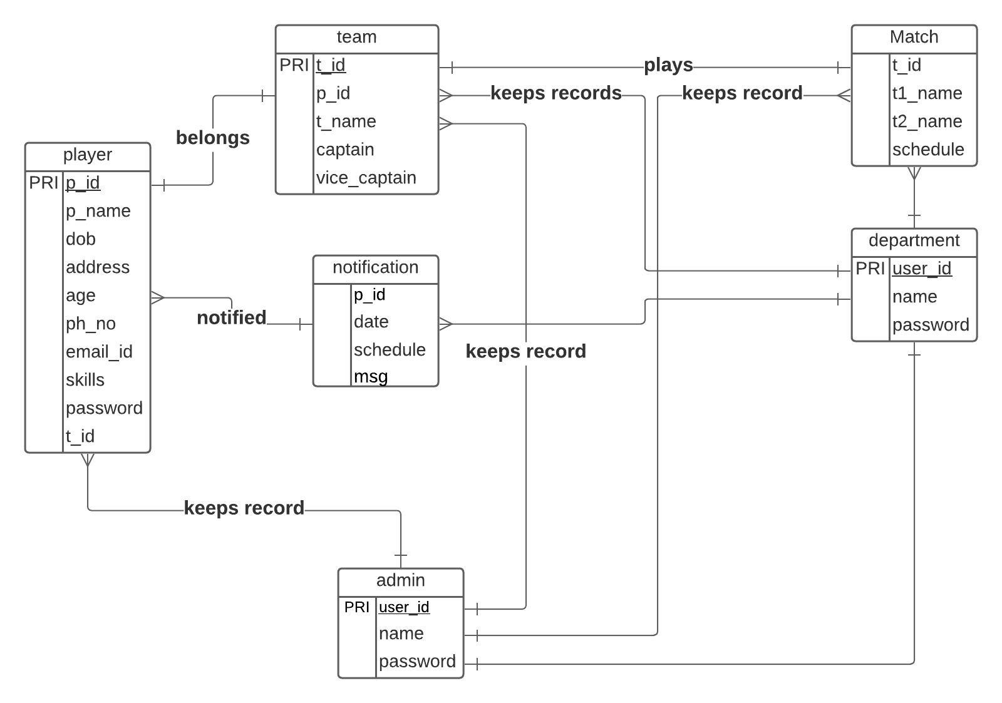

**6.5 Use Case Diagram**

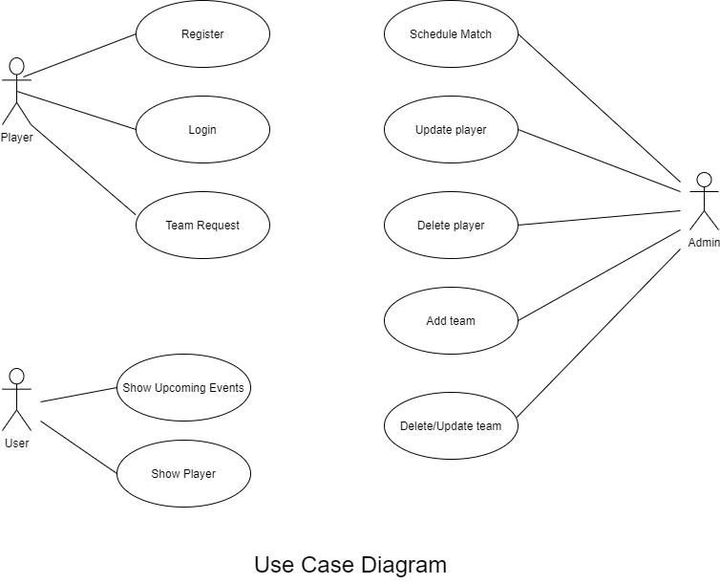

**7 . CODING**

7.1 Connectivity Code

<?php

    $server = "localhost";

    $user = "root";

    $password1 = "";

    $db = "cric_project";

    $con = mysqli_connect($server,$user,$password1,$db);

    if($con){

      ?>

         <script>

           //alert("Connection Successful");

           </script>

      <?php

    }else{

      ?>

         <script>

           alert("No Connection Successful");

         </script>

      <?php

    }

?>

7.2 DML Statement

* Player Insertion

<?php

     include 'conn.php';

        if(isset($_POST['submit1'])){

            $firstname = mysqli_real_escape_string($con,$_POST['firstname']);

            $lastname = mysqli_real_escape_string($con,$_POST['lastname']);

            $date = mysqli_real_escape_string($con,$_POST['date']);

            $age = mysqli_real_escape_string($con,$_POST['age']);

            $address = mysqli_real_escape_string($con,$_POST['address']);

            $number = mysqli_real_escape_string($con,$_POST['number']);

            $email = mysqli_real_escape_string($con,$_POST['email']);

            $skill = mysqli_real_escape_string($con,$_POST['skill']);

            $username = mysqli_real_escape_string($con,$_POST['username']);

            $password = mysqli_real_escape_string($con,$_POST['pass']);

            $cpassword = mysqli_real_escape_string($con,$_POST['cpass']);

$emailquery = "select * from player where email='$email'";

            $result = mysqli_query($con,$emailquery);

            $emailcount = mysqli_num_rows($result);

            if($emailcount>0){

                echo "email already exists";

            }else{

                if($password === $cpassword){

                     $insertquery = "insert into player(firstname,lastname,date,age,address,number,email,skill,username

                    ,password,cpassword) values('$firstname','$lastname','$date',$age,'$address','$number','$email','$skill','$username'

                    ,'$password','$cpassword')";

                    $iquery = mysqli_query($con,$insertquery);

                    if($iquery){

                        ?>

                           <script>

                             alert("Inserted Successfully");

                           </script>

                        <?php

* Player Updation

     $selectquery = "SELECT * FROM `player` WHERE id ='$id'";

     $query = mysqli_query($con,$selectquery);

     $arrdata = mysqli_fetch_array($query);

     if(isset($_POST['submit2'])){

        $id = $_GET['id'];

        $firstname =  $_POST['firstname'];

        $lastname =  $_POST['lastname'];

        $date =  $_POST['date'];

        $age =  $_POST['age'];

        $address =  $_POST['address'];

        $number =  $_POST['number'];

        $email =  $_POST['email'];

        $skill =  $_POST['skill'];

        $username =  $_POST['username'];

        $password =  $_POST['pass'];

        $cpassword =  $_POST['cpass'];

        //$insertquery = "insert into player(firstname,lastname,date,age,address,number,email,skill,username

        //,password,cpassword) values('$firstname','$lastname','$date',$age,'$address','$number','$email','$skill','$username'

        //,'$password','$cpassword')";

         $query = " update player set id=$id,firstname='$firstname',lastname ='$lastname',date='$date',age=$age,address='$address',

          number='$number',email='$email',skill='$skill',username='$username',password='$password',cpassword='$cpassword'

           where id=$id ";

         $iquery = mysqli_query($con,$query);

                    if($iquery){

                        ?>

                           <script>

                             alert("Data updated properly");

                             location.replace('profile.php');

                           </script>

                        <?php

                      }else{

                        ?>

                           <script>

                             alert("Data not updated");

                           </script>

                        <?php

                      }

* Player Delete

$deletequery = "delete from registration where id=$id";

$query = mysqli_query($con,$deletequery);

if($query){

    ?>

       <script>

         alert("Deleted Successfully");

       </script>

    <?php

      header('location:player.php');

  }else{

    ?>

       <script>

         alert("Not deleted");

       </script>

    <?php

  }

* Match scheduling

$sql="INSERT INTO `match_schedule` ( `team1`, `team2`, `matchdate`, `time`)VALUES( '$ team1', '$team2', '$matchdate', '$time');";

* Displaying

 <table *border*="4" *id*="show" *align*="center">

        <thead>

            <tr>

            <th> Team-1 Name</th>

            <th>Team-2 Name</th>

            <th>Match Date</th>

            <th>Match Time</th>

            </tr>

        </thead>

            <?php

            $sql = "SELECT * FROM `match_schedule`";

            $result = mysqli_query($con, $sql);

            while($row=mysqli_fetch_assoc($result)){?>

            <tr>

                <td><?php echo $row['team1']?></td>

                <td><?php echo $row['team2']?></td>

                <td><?php echo $row['date']?></td>

                <td><?php echo $row['time']?></td>

            </tr>

                <?php }?>

</table>

1. **GRAFICAL USER INTERFACE**



8.1 Homepage

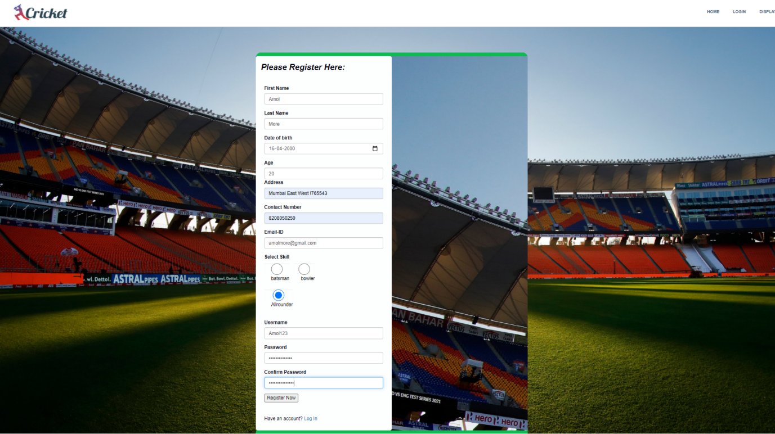

8.2 Player Registration Page

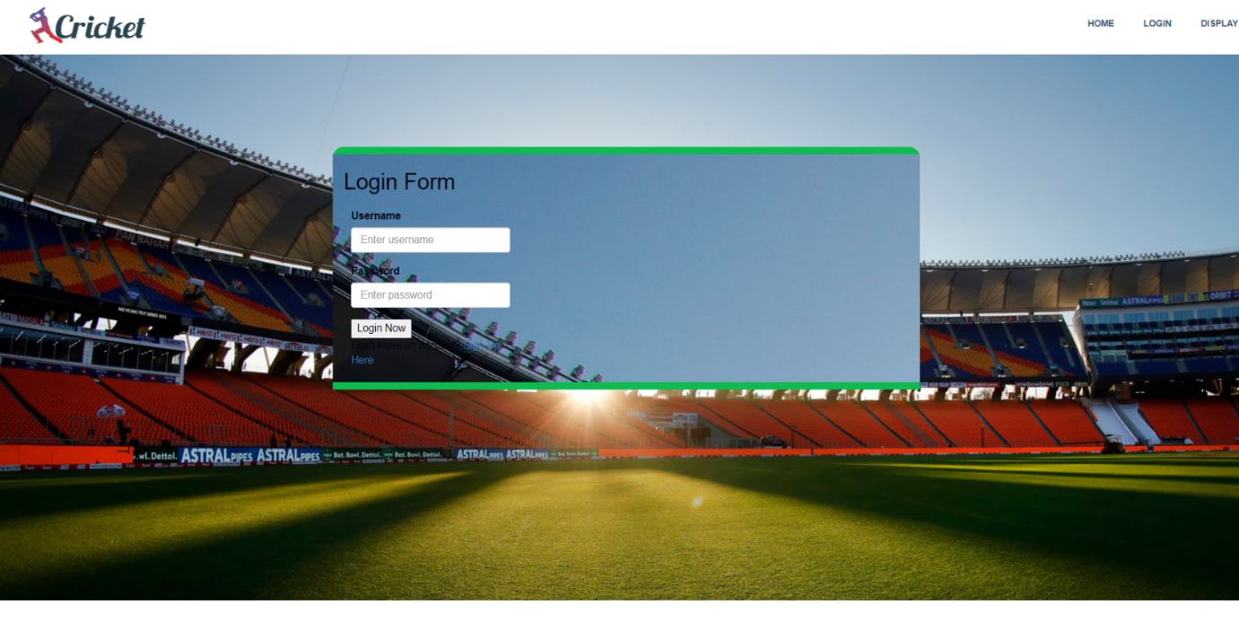

8.3 Player Login Page

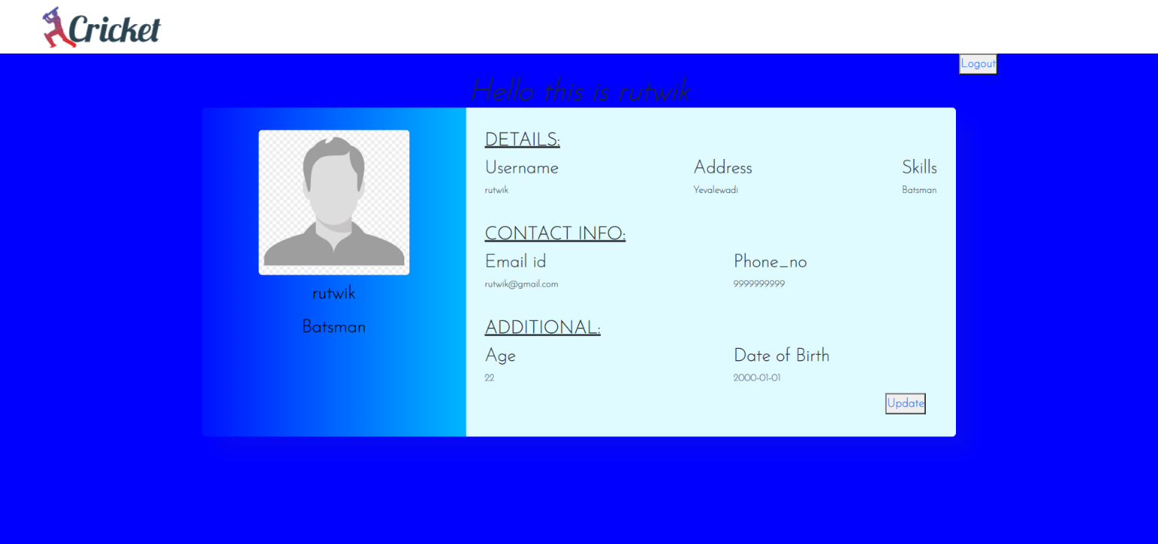

8.4 Player Profile Page

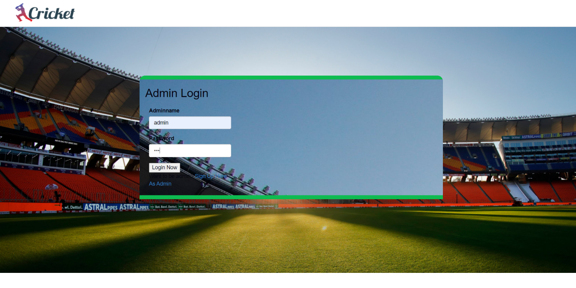

8.5 Admin Login Page

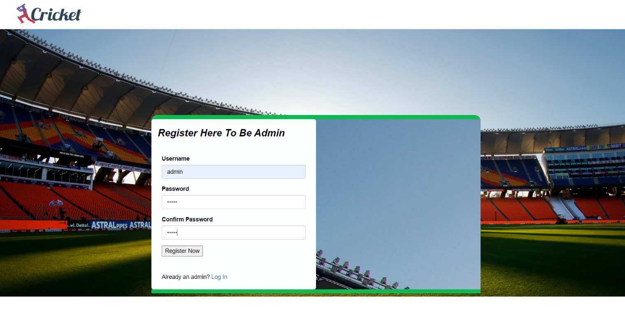

8.6 Admin Registration Page

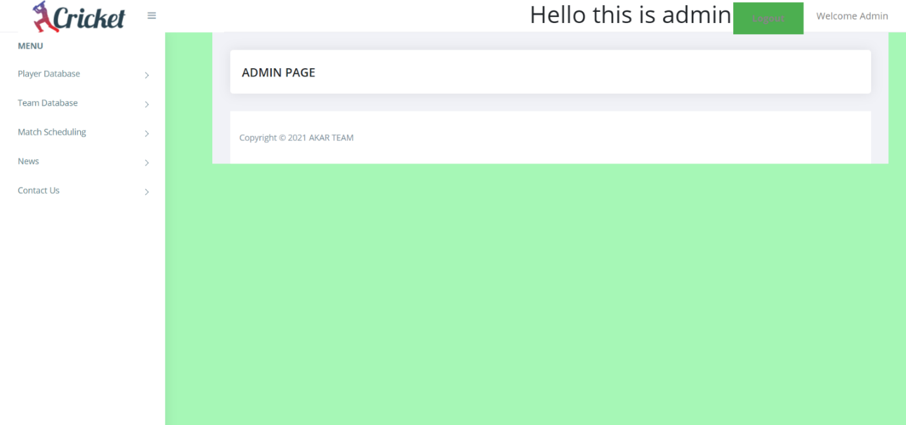

8.7 Admin Homepage

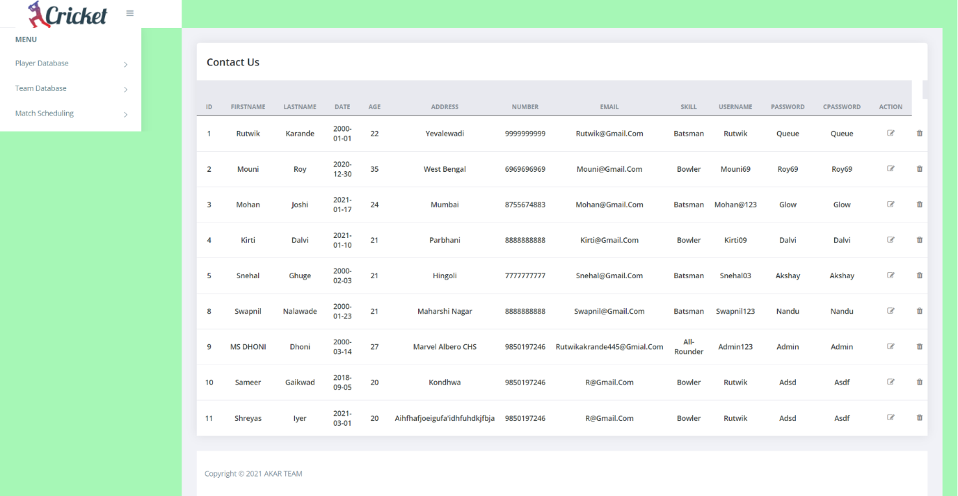

8.8 Player Database with Action Button for Update and Delete

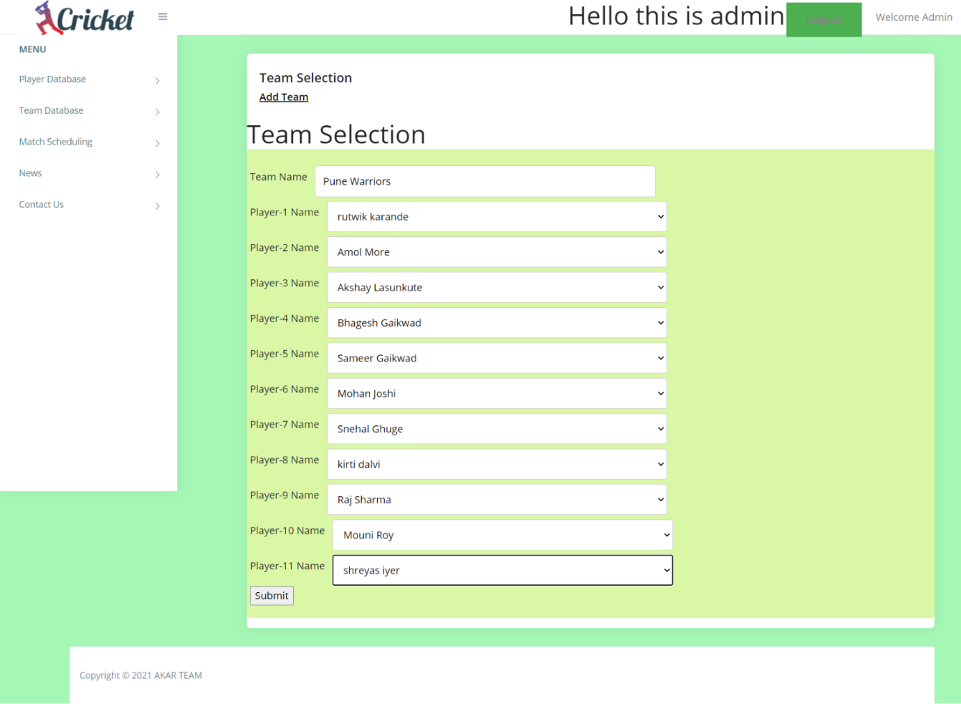

8.9 Team Register Page

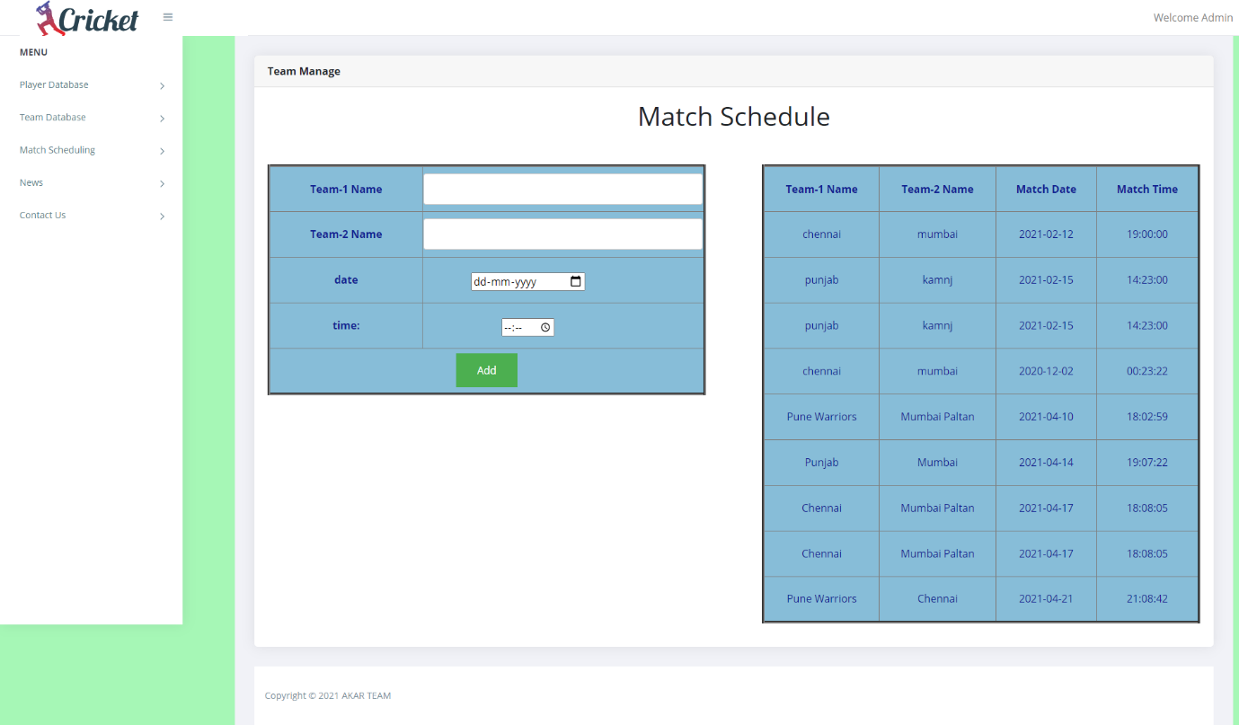

8.10 Match Scheduling Page

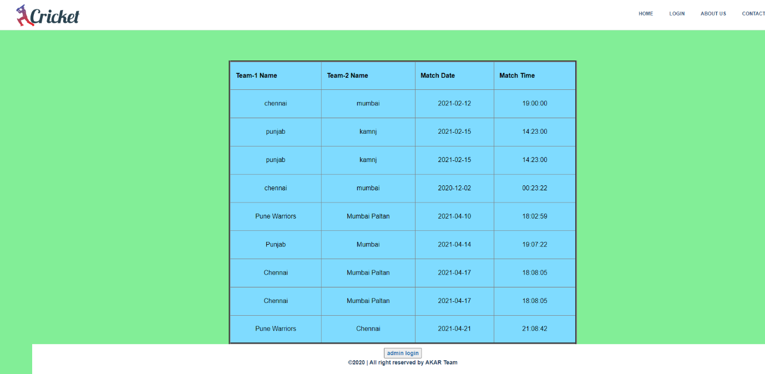

8.11 Display Page For Upcoming Events

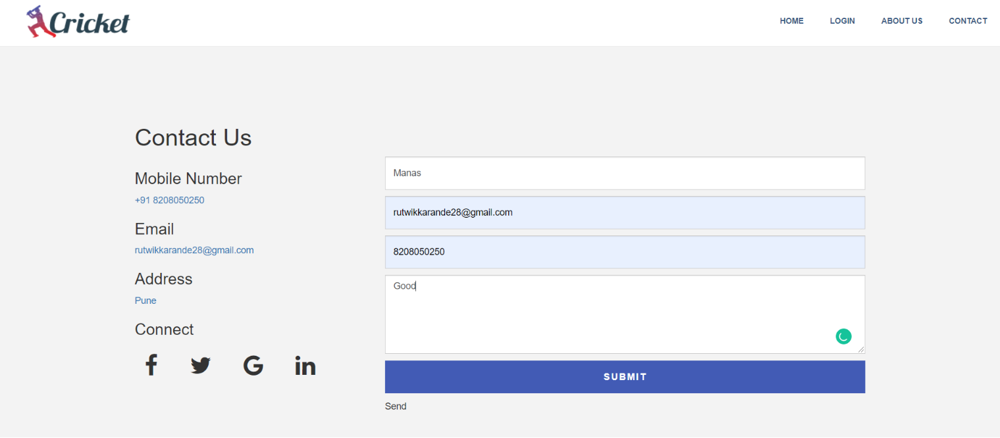

8.12 Contact Us Page



8.13 About Us Page

1. **FUTURE SCOPE**

The System would store all the games data of matches played between different teams. A cricket fan would be much delighted to look up for scores and key moments from matches through this system. It will be easier for team scouts to look up for new talent for their teams.

Hence, the deserving player will get a great opportunity that he or she wants to showcase their talent.

**10. CONCLUSION**

In our Cricket Management System, the system will allow to create multiple tournaments by tournament owners. Player and Tournament owner are the users of the system. In our system, match scheduling can be done automatically or manually. It provides statistics of the match and also maintain player log. Player can view their profile, previous records and player log also can be managed. Player get notification before start of the match as a reminder. Admin upload news and gallery. Admin can manage news and gallery. It will avoid duplication of tournament for a player, team and game.

Thus we gain a deep knowledge about database management system. Different DDL, DML statements were executed and studied thoroughly.

**11. REFERENCES**

[1]<https://www.tutorialspoint.com/index.htm>

[2] <https://www.w3schools.com>

[3] <https://www.javatpoint.com>

[4] https://dev.mysql.com/downloads/mysql/